Data Set: Warehouse and Retail Sales
https://catalog.data.gov/dataset/warehouse-and-retail-sales

Problem Statement:
This project analyzes warehouse and retail sales data to determine whether wine generates higher retail sales than other item types in the dataset. The data contains item types and retail sales values, which can be used to compare the total retail sales between different categories.

Hypothesis:
Wine will have a higher total amount of retail sales than the other item types found in the dataset.

How it will be tested:
The dataset will be separated by item type, and the retail sales values for each category will be summed. Using command-line tools such as awk, the total retail sales for each item type will be calculated and compared. The results will then be analyzed to determine whether wine has the highest total retail sales among the item categories.

Screenshots:

Git Clone, adding csv, and pushing with a commit (started in command prompt before switching to git bash for future steps)
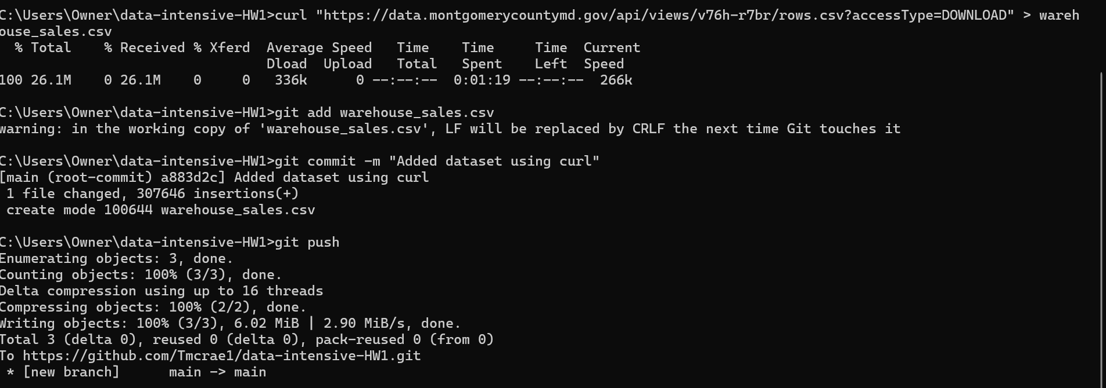

head (Now in Git Bash)
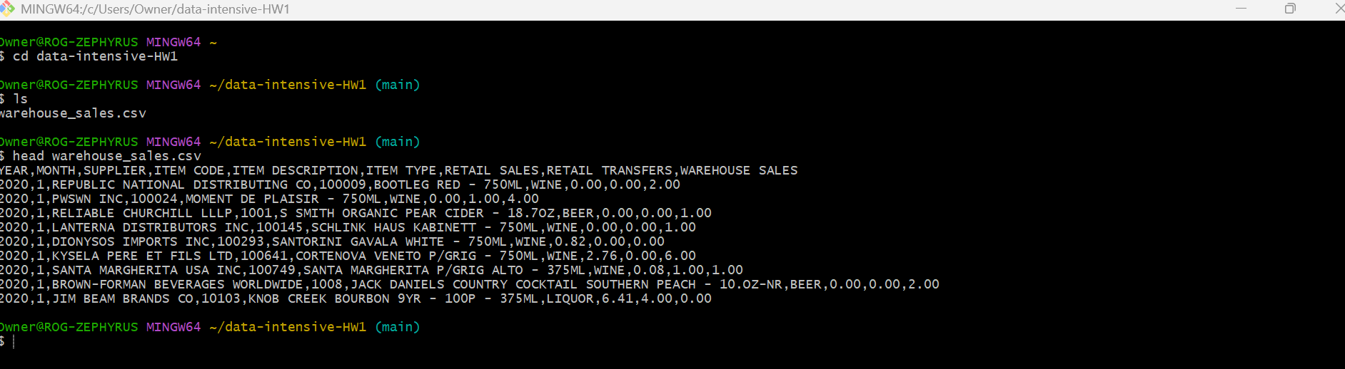

Used awk to make item_sales.csv (file has columns item_type and retail sales from warehouse_sales.csv)
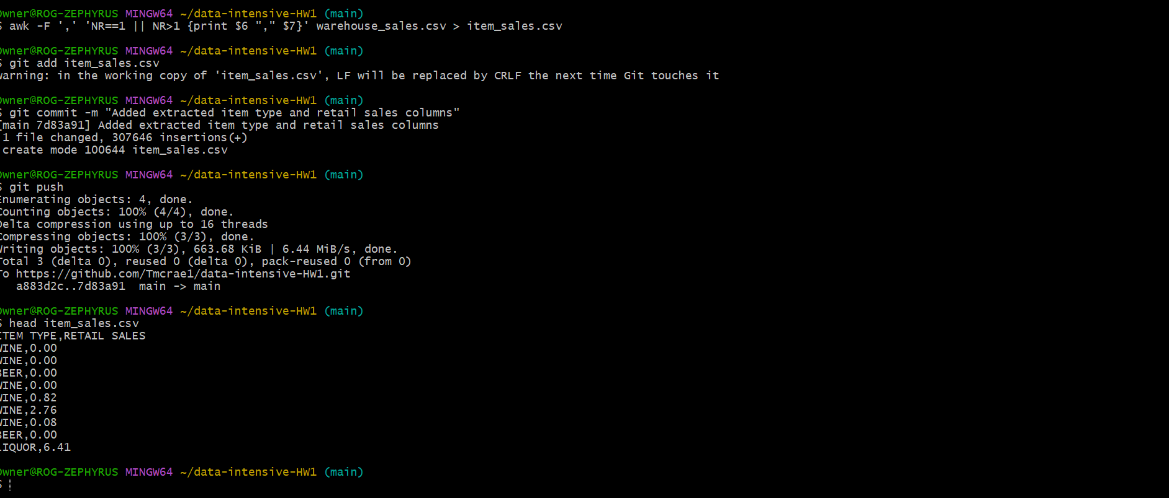

Results from running awk command to find total retail sales of each item type
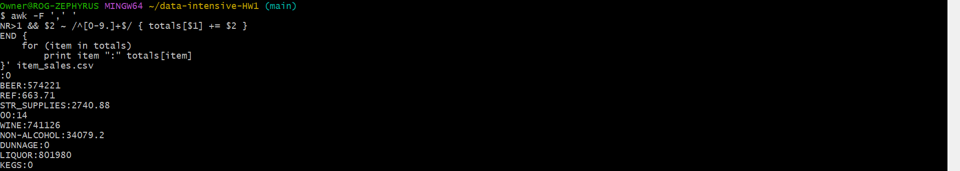

Early Conclusions:
Based on the data found by doing the awk command (to find the sum of the retail sales of each item) it could be concluded that liquor retail sales are the highest among the various item types at the warehouse and not wine like I thought in my hypothesis. This may suggest that liquor is a more popular item from the warehouse compared to the other item types while wine is still a somewhat popular item from the warehouse.

